Graphic Organizer

British
Action
Colonial
Reaction
British
Reaction

The
Stamp
Act

Protests such as boycotts

Repeal of the Stamp Act

The
Townsend
Acts

Mass. Circular Letter

Mass. Legislature is dissolved

Big Ideas Card

Big Ideas of Lesson 4, Unit 5
- As a way to raise money, the British Parliament passed the Sugar Act and Stamp Act. These acts taxed the colonists.
- Although the Stamp Act was repealed, Britain continued to anger many colonists by passing new acts such as the Townshend Acts.
- Colonial protests of these acts included boycotts of British goods, demonstrations, violent protest, and petitions to the King and Parliament.
- The colonists communicated through Committees of Correspondence and Circular Letters.
- Some colonists remained loyal to the king. They did not protest British actions.
- In an attempt to show its authority over the colonies Britain sent more soldiers to the colonies.

Word Cards

Word Cards from previous lessons needed for this lesson:

- Authority – Word Card #6 from Lesson 2
- Writs of Assistance - Word Card #9 from Lesson 3
- Quarter – Word Card #12 from Lesson 3
- Sons of Liberty – World Card #15 from Lesson 3

16  import    a good that a country or  region buys from another  country or region  Example: The colonies imported many goods from Britain.  (SS050504) |   17  boycott  when people refuse  to have dealings or trade  with another person or company in order to show disapproval  Example: To protest the Stamp Act some colonists boycotted British goods.  (SS050504)
18  Committees of Correspondence  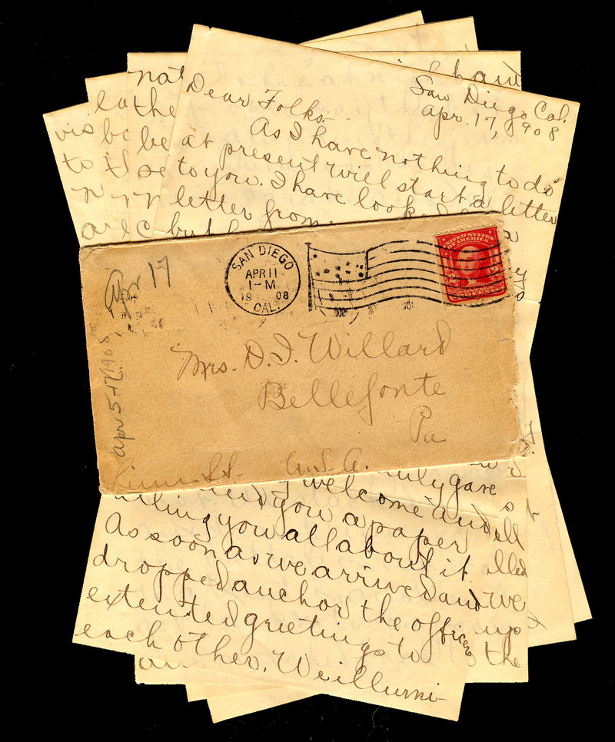  Groups that formed in order to communicate between the colonies.  Example: Committees of Correspondence helped colonial legislatures communicate with each other.  (SS050504) | 19  grievances  complaints    Example: The colonists had many grievances against Britain including Britain’s taxing of the colonists.  (SS050504)
20  government by consent    people have to agree to be governed  Example: Britain did not have the consent of the governed when it taxed the colonists.  (SS050504) | 21  right to petition    the right to issue a written request or complaint to an authority  Example: Colonists felt they had the right to petition the King about their grievances.  (SS050504)
  22  repeal  to take back a law  or act  Example: The British repealed the Stamp Act.  (SS050504) | 23  ☺  loyalists    Colonists who remained loyal to the king  Example: Loyalists felt the King and Parliament should have full authority over the colonies. (SS050504)
24  ☹  patriots  colonists who protested against the British  Example: Patriots opposed British actions such as the Stamp Act and the Townshend Acts.  (SS050504) |   25  Circular Letter  A letter that moved  around from colony to colony  Example: James Otis wrote a Circular Letter that began in Massachusetts and then went to other colonies.  (SS050504)

Analyzing Data – Graph #1

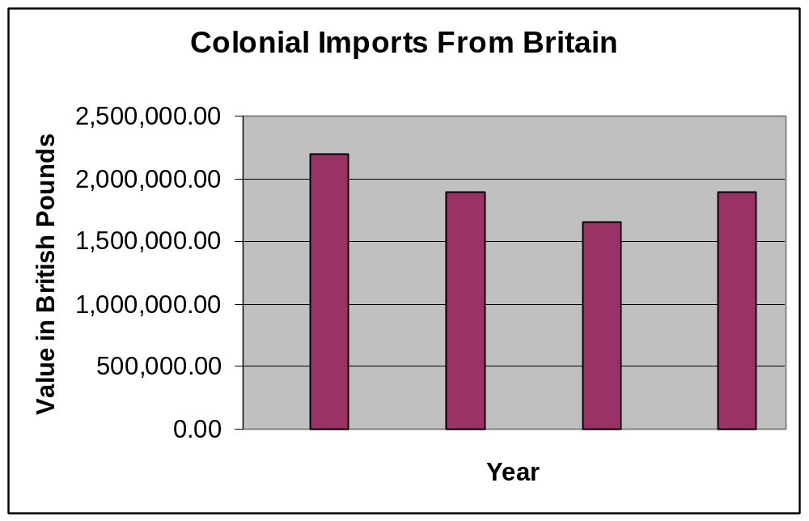
1765
1764
1766

What is shown on this graph?

What conclusion can you draw from the data?

How might this graph be related to colonial protests against the Stamp Act?

Analyzing Data – Graph #1– Possible Answers

1765
1764
1766

What is shown on this graph?

This graph shows the value of imported goods from Britain into the colonies for the years 1764, 1765, and 1766.

What conclusion can you draw from the data?

There was a decrease in colonial imports from Britain between 1764 and 1766.

How might this graph be related to colonial protests against British taxes?

Colonist may have decided to buy fewer British goods as a protest against the Stamp Act and other actions by the British.

Declaration of Rights and Grievances

What does it mean?
GROUP 1
That His Majesty's . . . subjects in these colonies, are entitled to all the inherent rights and liberties of his natural born subjects within the kingdom of Great-Britain.
GROUP 2
That it is . . . essential to the freedom of a people, and the . . . right of Englishmen, that no taxes be imposed on them, but with their own consent, given personally, or by their representatives.
GROUP 3
That the only representatives of the people of these colonies are persons chosen therein by themselves, and that no taxes ever have been, or can be constitutionally imposed on them, but by their respective legislatures.
GROUP 4
That the restrictions imposed by several late Acts of Parliament, on the trade of these colonies, will render them unable to purchase the manufactures of Great Britain.
GROUP 5
That it is the right of the British subjects in these colonies, to petition the King, Or either House of Parliament.

Declaration of Rights and Grievances – Sample Answers

 | What does it mean?
GROUP 1  That His Majesty's . . . subjects in these colonies, are entitled to all the inherent rights and liberties of his natural born subjects within the kingdom of Great-Britain. | The colonists were entitled to the same rights and freedoms as British people have in Britain.
GROUP 2  That it is . . . essential to the freedom of a people, and the . . . right of Englishmen, that no taxes be imposed on them, but with their own consent, given personally, or by their representatives. | That it was the right of British citizens to only be taxed by their own elected representatives. They had to give their consent, or agree, to be taxed.
GROUP 3  That the only representatives of the people of these colonies, are persons chosen therein by themselves, and that no taxes ever have been, or can be constitutionally imposed on them, but by their respective legislatures. | The only representatives of the colonists were those chosen to represent them in their colonial legislatures. Only the colonial legislatures could tax them.
GROUP 4  That the restrictions imposed by several late Acts of Parliament, on the trade of these colonies, will render them unable to purchase the manufactures of Great Britain. | The Stamp Act would result in colonists being unable to buy British goods.
GROUP 5  That it is the right of the British subjects in these colonies, to petition the King, Or either House of Parliament. | The colonists as British subjects had the right to petition, or complain to, the King or Parliament about their complaints.

Primary Source
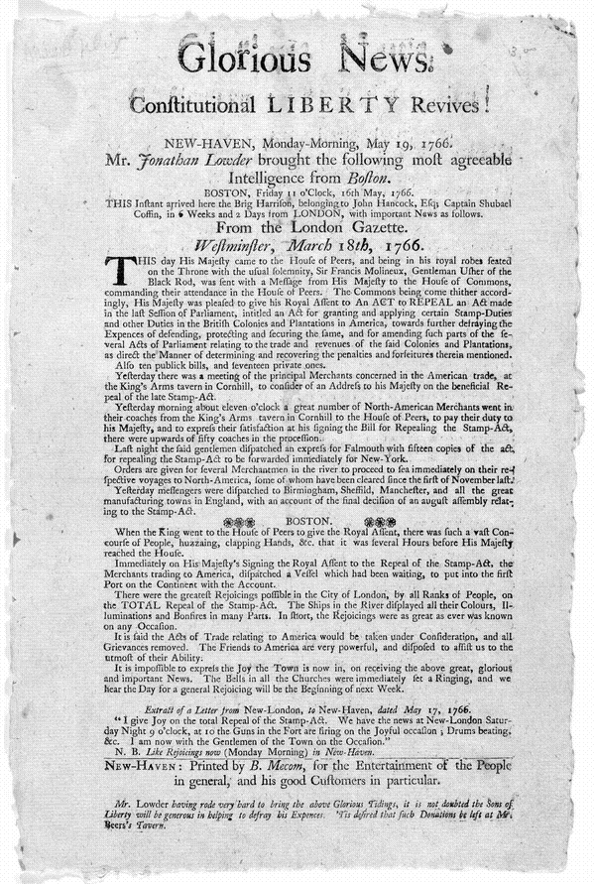
Source: Library of Congress. http://www.loc.gov/teachers/classroommaterials/presentationsandactivities/presentations/timeline/amrev/britref/news.html

Primary Source Analysis

What kind of a primary source is this?

How do you know?

What important event does it describe?

Directions: Write the meaning of each of the phrases on the chart in your own words.

Glorious News
Constitutional Liberty Revives
Most agreeable Intelligence from Boston
Mr. Lowder having rode very hard to bring the above Glorious Tidings, it is not doubted the Sons of Liberty will be gnerous in helping to defray his Expenses.

Transcription of Primary Source
(with original spellings)

Glorious News.
Constitutional LIBERTY Revives!
New-Haven, Monday-Morning, May 19, 1766
Mr. Jonathan Lowder brought the following most agreeable Intelligence from Boston.
BOSTON, Friday 11 o'Clock, 16th May, 1766.
THIS Instant arrived here the Brig Harrison, belonging to John Hancock, Esq; Captain Shaubael Coffin in 6 Weeks and 2 Days from LONDON, with important News as follows.
From the London Gazette.
Westminster, March 18th, 1766.
THIS day His Majesty came to the House of Peers, and being in his royal robes seated on the Throne with the usual solemnity, Sir Francis Molineaux, Gentleman Usher of the Black Rod, was sent with a Message from His Majesty to the House of Commons, commanding their attendance in the House of Peers. The Commons being come thither accordingly, His Majesty was pleased to give his Royal Assent to An ACT to REPEAL an Act made in the last Session of Parliament, intitled an Act for granting and applying certain Stamp-Duties and other Duties in the British Colonies and Plantations in America, towards further defraying the Expences of defending, protecting and securing the same, and for amending such parts of the several Acts of Parliament relating to the trade and revenues of the said Colonies and Plantations, as direct the Manner of determining and recovering the penalities and forteitures therein mentioned.
Also ten publick bills, and seventeen private ones.
Yesterday there was a meeting of the principal Merchants concerned with the American trade, at the King's Arms tavern in Cornhill, to consider of an Address to his Majesty on the beneficial Repeal of the late Stamp-Act.
Yesterday morning about eleven o'clock a great number of North-American Merchants went in their coaches from the King's Arms tavern in Cornhill to the House of Peers, to pay their duty to his Majesty, and to exprfess their satisfaction at his signing the Bill for Repealing the Stamp-Act, there were upwards of fifty coaches in the procession.
Transcription of Artifact, con’t

Last night the said gentlemen dispatched an express for Falmouth with fifteen copies of the act, for repealing the Stamp-Act to be forwarded immediately for New-York.
Orders are given for several Merchantmen in the river to proceed to sea immediately on their respective voyages to North-America, some of whom have been cleared since the first of November last.
Yesterday messengers were dispatched to Birmingham, Sheffild, Manchester, and all the great manufacturing towns in England, with an account of the final decision of an august assemply relating to the Stamp-Act.
[From] BOSTON.
When the King went to the House of Peers to give the Royal Assent, there was such a vast Concourse of People, huzzaing, clapping Hands, Etc. that it was several Hours before His Majesty reached the House.
Immediately on His Majesty's Signing the Royal Assent to the Repeal of the Stamp-Act, the Merchants trading to America, dispatched a Vessel which had been waiting, to put into the first Port on the Continent with the Account.
There were the greatest Rejoicings possible in the City of London, by all Ranks of People, on the TOTAL Repeal of the Stamp Act. The Ships in the River displayed all their Colours, Illuminations and Bonfires in many Parts. In short, the Rejoicings were as great as evern was known on any Occasion.
It is said the Acts of Trade relating to America would be taken under Consideration, and all Grievances removed. The Friends of America are very powerful, and disposed to [assist] us to the utmost of their Ability.
It is impossible to express the Joy the Town is now in, on receiving the above great, glorious and important News. The Bells in al the Churches were immediately set a Ringing, and we hear the Day for a generaly Rejoicing will be the Beginning of next Week.

Primary Source Analysis – Answer Sheet

What kind of a primary source is this?

Some type of newspaper article (Technically it’s a pamphlet but students are not likely to know this.)

How do you know?

It has a headline and a date. It is written like a newspaper article.

What important event does it describe?

The Repeal of the Stamp Act which must mean it will not be a law anymore.

Directions: Write the meaning of each of the phrases on the chart in your own words.

Glorious News | Good news
Constitutional Liberty Revives | Freedom lives again
Most agreeable Intelligence from Boston | Good news from Boston
Mr. Lowder having rode very hard to bring the above Glorious Tidings, it is not doubted the Sons of Liberty will be generous in helping to defray his Expenses. | Mr. Lowder brought the news and the trip cost him money. Hopefully, the Sons of Liberty will help to pay him back.

The Declaratory Act

An act for the better securing the dependency of his majesty's dominions in America upon the crown and parliament of Great Britain.

Whereas several of the houses of representatives in his Majesty's colonies and plantations in America, have of late against law, claimed to themselves, or to the general assemblies of the same, the sole and exclusive right of imposing duties and taxes upon his majesty's subjects in the said colonies and plantations… may it be declared That the said colonies and plantations in America have been, are, and of right ought to be, subordinate unto, and dependent upon the imperial crown and parliament of Great Britain and that the King's majesty with parliament assembled have, full power and authority to make laws and statutes of sufficient force and validity to bind the colonies and people of America, subjects of the crown of Great Britain, in all cases whatsoever.

Analyzing Data – Graph #2

1765
1764
1766
1767

Massachusetts Circular Letter of 1768

The House of Representatives of this province, have taken into their serious consideration, the great difficulties that must accrue to themselves and their constituents, by the operation of several acts of Parliament, imposing duties and taxes on the American colonies.
As it is a subject in which every colony is deeply interested, they have no reason to doubt but your House is deeply impressed with its importance, and that such constitutional measures will be come into, as are proper. It seems to be necessary, that all possible care should be taken, that the representatives of the several assemblies, upon so delicate a point, should harmonize with each other.

Source: http://www.revolutionary-war-and-beyond.com/massachusetts-circular-letter-february-11-1768.html

Assessment
British
Action
Colonial
Reaction
British
Reaction

Complete the graphic below by listing a British Action, Colonial Reaction to that action and finally, the British reaction to the Colonists.
British
Action
Colonial
Reaction
British
Reaction

British
Action
Colonial
Reaction
British
Reaction

