Graphic Organizer

Britain sends more soldiers to the Colonies especially to the city of Boston.
Conflicts increase between colonists and British soldiers in Boston.
The Boston Massacre occurs in 1773.
Many colonists are very angry about the Boston Massacre.
Anger increases as the British pass the Tea Act of 1773.
The Boston Tea Party occurs in December of 1773.
Britain passes the Intolerable Acts in 1774 to punish Boston for the Tea Party.

Big Ideas Card

Big Ideas of Lesson 5, Unit 5
- Boston became a leading center of patriot protest. Because of this, Britain sent more soldiers to Boston.
- Conflicts increased between colonists and British soldiers.
- This led to the Boston Massacre in 1770. Viewpoints of this event differed between the British and the patriots.
- Britain passed a Tea Act in 1773. The Boston Tea Party occurred as a protest of this act.
- Britain passed the Intolerable Acts to punish Boston for the Tea Party.

Word Cards

Word Cards from previous lessons needed for this lesson:

- Authority – Word Card #6 from Lesson 2
- Writs of Assistance - Word Card #9 from Lesson 3
- Quarter – Word Card #12 from Lesson 3
- Sons of Liberty – World Card #15 from Lesson 3
- Boycott – Word Card #17 from Lesson 4
- Committees of Correspondence – Word Card #18 from Lesson 4
- Loyalists – Word Card #23 from Lesson 4
- Patriots – Word Card #24 from Lesson 4

26  massacre  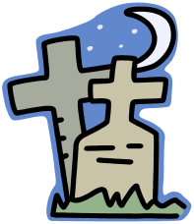  the killing of a large number of people who are usually helpless  Example: The “Boston Massacre” occurred in 1770.  (SS050505) |   27  monopoly  complete control of a  product or service  Example: The Tea Act gave one British company a monopoly on the sale of tea.  (SS050505)
Primary Source #1
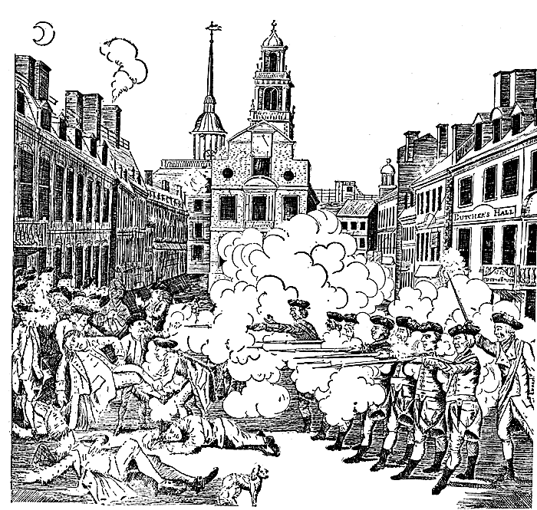

Primary Source #2
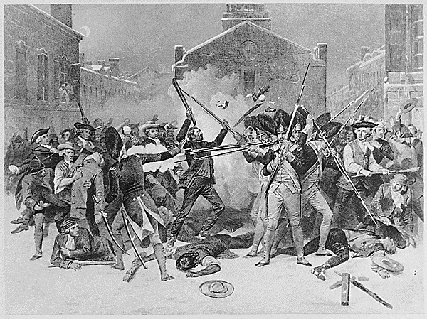

Source: National Archives. http://www.archives.gov/research/arc/.
The British point of view:
Excerpt from the report of Captain Thomas Preston:
...In my way there I saw the people in great commotion, and heard them use the most cruel and horrid threats against the troops. In a few minutes after I reached the guard, about 100 people passed it and went towards the custom house where the king's money is lodged. They immediately surrounded the sentry posted there, and with clubs and other weapons threatened to execute their vengeance on him. I was soon informed by a townsman their intention was to carry off the soldier from his post and probably murder him... I immediately sent a noncommissioned officer and 12 men to protect both the sentry and the king's money, and very soon followed myself to prevent, if possible, all disorder, fearing lest the officer and soldiers, by the insults and provocations of the rioters, should be thrown off their guard and commit some rash act. They soon rushed through the people, and by charging their bayonets in half-circles, kept them at a little distance... The mob still increased and were more outrageous, striking their clubs or bludgeons one against another, and calling out, come on you rascals… you lobster scoundrels, fire if you dare…and much more such language was used. At this time I was between the soldiers and the mob, parleying with, and endeavouring all in my power to persuade them to retire peaceably, but to no purpose. They advanced to the points of the bayonets, struck some of them and even the muzzles of the pieces, and seemed to be endeavouring to close with the soldiers. On which some well behaved persons asked me if the guns were charged. I replied yes. They then asked me if I intended to order the men to fire. I answered no, by no means, observing to them that I was advanced before the muzzles of the men's pieces, and must fall a sacrifice if they fired ...While I was thus speaking, one of the soldiers having received a severe blow with a stick, stepped a little on one side and instantly fired, on which turning to and asking him why he fired without orders, I was struck with a club on my arm, which for some time deprived me of the use of it, which blow had it been placed on my head, most probably would have destroyed me.
On this a general attack was made on the men by a great number of heavy clubs and snowballs being thrown at them, by which all our lives were in imminent danger, some persons at the same time from behind calling out, why don't you fire. Instantly three or four of the soldiers fired, one after another, and directly after three more in the same confusion and hurry. The mob then ran away, except three unhappy men who instantly expired, in which number was Mr. Gray at whose rope-walk the prior quarrels took place; one more is since dead, three others are dangerously, and four slightly wounded. The whole of this melancholy affair was transacted in almost 20 minutes. On my asking the soldiers why they fired without orders, they said they heard the word fire and supposed it came from me. This might be the case as many of the mob called out fire, fire, but I assured the men that I gave no such order; that my words were, don't fire, stop your firing. In short, it was scarcely possible for the soldiers to know who said fire, or don't fire, or stop your firing.

The American Point of View:
From an anonymous source:

THE HORRID MASSACRE IN BOSTON, PERPETRATED IN THE EVENING OF THE FIFTH DAY OF MARCH, 1770, BY SOLDIERS OF THE TWENTY-NINTH REGIMENT WHICH WITH THE FOURTEENTH REGIMENT WERE THEN QUARTERED THERE; WITH SOME OBSERVATIONS ON THE STATE OF THINGS PRIOR TO THAT CATASTROPHE

...Whether the boys mistook the sentry for one of the said party (a group of unruly soldiers who had been about the area earlier), and thence took occasion to differ with him, or whether he first affronted them, which is affirmed in several depositions,-however that may be, there was much foul language between them, and some of them, in consequence of his pushing at them with his bayonet, threw snowballs at him, which occasioned him to knock hastily at the door of the Custom House. From hence two persons thereupon proceeded immediately to the main-guard, which was posted opposite to the State House, at a small distance, near the head of the said street. The officer on guard was Capt. Preston, who with seven or eight soldiers, with firearms and charged bayonets, issued from the guardhouse, and in great haste posted himself and his soldiers in front of the Custom House, near the corner aforesaid. In passing to this station the soldiers pushed several persons with their bayonets, driving through the people in so rough a manner that it appeared they intended to create a disturbance. This occasioned some snowballs to be thrown at them which seems to have been the only provocation that was given. Mr. Knox (between whom and Capt. Preston there was some conversation on the spot) declares, that while he was talking with Capt. Preston, the soldiers of his detachment had attacked the people with their bayonets and that there was not the least provocation given to Capt. Preston of his party; the backs of the people being toward them when the people were attacked. He also declares, that Capt. Preston seemed to be in great haste and much agitated, and that, according to his opinion, there were not then present in King street above seventy or eighty persons at the extent. The said party (British soldiers) was formed into a half circle; and within a short time after they had been posted at the Custom House, began to fire upon the people. Captain Preston is said to have ordered them to fire, and to have repeated that order. One gun was fired first; then others in succession and with deliberation, till ten or a dozen guns were fired; or till that number of discharges were made from the guns that were fired. By which means eleven persons were killed and wounded, as above represented.

Source: http://www.historywiz.com/primarysources/eyewit-boston.htm>.

Comparison Chart

 | British Viewpoint | American Viewpoint
How many Americans were there?
Words used to describe the Americans
Words used to describe the soldiers
What were the Americans carrying?
What did the Americans do?
What did the soldiers do?
How did the firing start?
Who told the soldiers to fire?
How many were killed?
What was the event called?
What is another difference you notice?

Comparison Chart – Sample Answers

 | British Viewpoint | American Viewpoint
How many Americans were there? | about 100 | 70 to 80
Words used to describe the Americans | rioters, mob, outrageous, | the people, boys,
Words used to describe the soldiers | soldiers, the men | unruly, armed with guns and bayonets
What were the Americans carrying? | snowballs | clubs and other weapons
What did the Americans do? | surrounded the soldiers with clubs, threatened them | threw snowballs
What did the soldiers do? | defended themselves and kept the mob at a distance | pushed people with their bayonets, pushed them in a rough manner
How did the firing start? | soldier received a severe blow with a stick, stepped to one side and fired | within a short time after they were posted they began to fire upon the people – only provocation was the throwing of snowballs
Who told the soldiers to fire? | it was hard to tell – some of the mob had been calling our “fire”, “fire” | Captain Preston
How many were killed? | 3 killed, one more later, 3 seriously wounded and 4 slightly wounded | 11 killed and wounded
What was the event called? | a melancholy affair | a horrid massacre
What is another difference you notice? | Answers will vary. | Answers will vary.

Revolutionary Tea

There was an old lady lived over the sea
And she was an island queen.
Her daughter lived off in a new country
With an ocean of water between
The old lady’s pockets were full of gold
But never contented was she,
So she called on her daughter to pay her a tax
Of three pence a pound on her tea,
Of three pence a pound on her tea.

Source: Discovery School. <http://school.discovery.com/lessonplans/programs/revwar1/>.

The Boston Tea Party

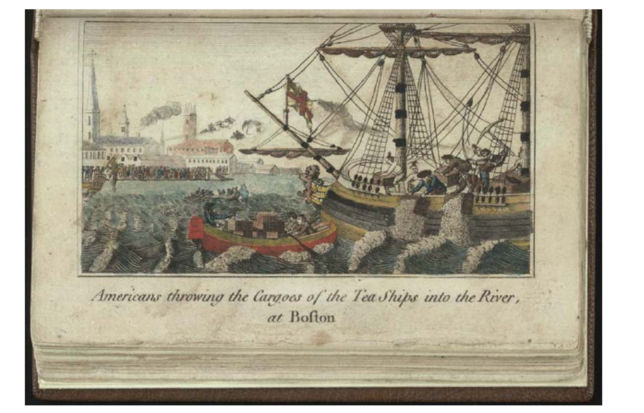

Source: The Boston Tea Party. Library of Congress, Rare Book and Special Collections Division, Washington, D.C.
The Intolerable Acts

- The Boston Port Bill passed in March of 1774. It closed the Port of Boston until the colonists paid for the tea they destroyed.
- To enforce the law, Parliament ordered the British navy to blockade Boston Harbor. Warships were used to prevent other ships from entering or leaving.
- The Massachusetts Government Act stopped the Massachusetts legislature from making laws and banned town meetings that were not authorized by the royal governor.
- A new Quartering Act ordered that colonists in Boston had to quarter British soldiers.

The Edenton Tea Party
Oct. 25, 1774
“The Provincial Deputies of North Carolina, having resolved not to drink any more tea, nor wear any more British cloth, many ladies of this province have determined to give memorable proof of their patriotism, and have accordingly entered into the following honourable and spirited association. I send it to you to shew your fair countrywomen, how zealously and faithfully, American ladies follow the laudable example of their husbands, and what opposition your matchless Ministers may expect to receive from a people thus firmly united against them.”
“We cannot be indifferent on any occasion that appears nearly to affect the peace and happiness of our country, and . . . it is a duty which we owe, not only to our near and dear connections, . . . but to ourselves. . . .”
Assessment

What are two things the British used their power to do under the Intolerable Acts?

1. __________________________________________________________________________

___________________________________________________________________________

2. __________________________________________________________________________

___________________________________________________________________________

Do you think the British thought they had the authority to do this? Explain your answer.

Do you think colonial leaders like Samuel Adams thought the British government had the authority to do this? Explain your answer.

Do you think the British had the authority to do this? Explain your answer.

People like Samuel Adams and Joseph Warren wanted to limit the power of the British government. Why do you think they wanted to do this?

Assessment – Sample Answers

What are two things the British used their power to do under the Intolerable Acts?

1. closed the Port of Boston

2. stopped town meetings

Do you think the British thought they had the authority to do this? Explain your answer.

The British thought they had the authority because they believed the colonies were there to benefit Britain. When the people in Boston destroyed British property, Parliament believed it had the authority to punish Boston.

Do you think colonial leaders like Samuel Adams thought the British government had the authority to do this? Explain your answer.

People like Samuel Adams thought the British government did not have the authority to stop town meetings because colonists had the right to self-government through a legiislature just like citizens in Britain. They did not have the authority to close a colonial port either. They used power without authority.

Do you think they had the authority to do this? Explain your answer.

Answers will vary.

People like Samuel Adams and Joseph Warren wanted to limit the power of the British government. Why do you think they wanted to do this?

By closing the port of Boston and banning town meetings, people like Samuel Adams felt the British had overstepped their authority. They felt there had to be a limit on British authority in order to protect the rights and liberties of colonists.

